
Beaconsfield Constituency Conservative Association

Beaconsfield Branch invite you to join them on a
Visit to RAF Museum Uxbridge
Including WWII Bunker
A brand new museum including the original operations centre for Fighter Command No 11 Group during WWII

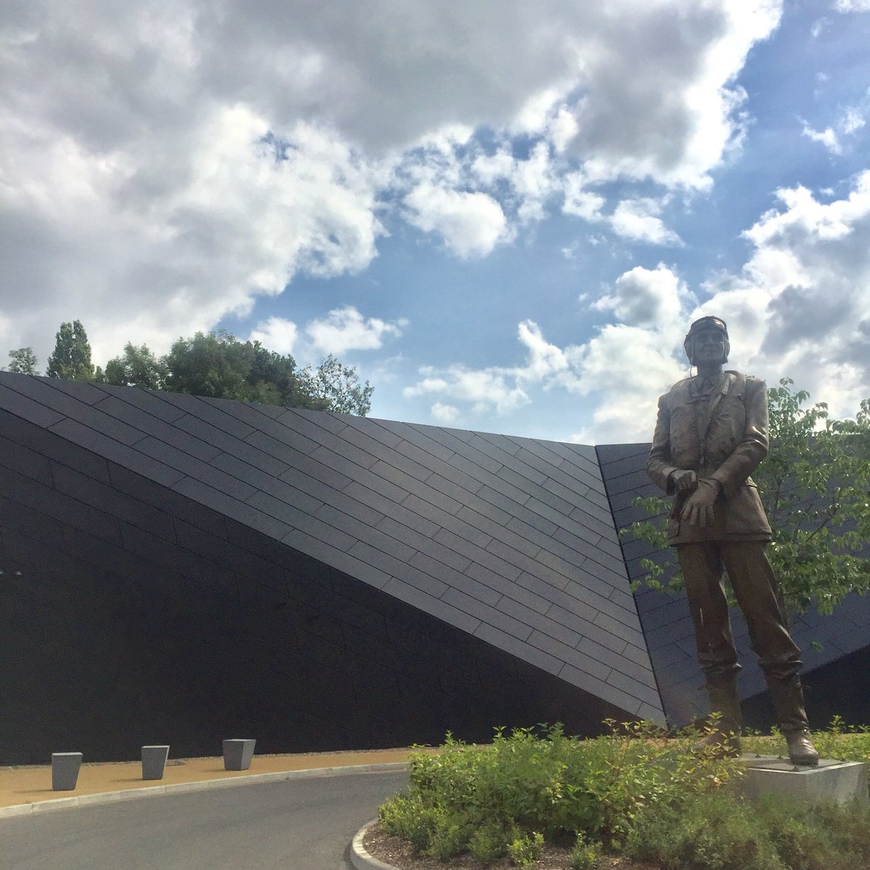

Tuesday 25th September 2018

Leaving by car from The Beacon Centre at 9.30am sharp and Wildwood, Gerrards Cross at 9.40am

Tickets: £25 per person
Including car & entrance to The Museum

Returning by 4.30pm to Beaconsfield (Beacon Centre)

Applications please by 15th September to Pat Foote

-----------------------------------------------------------------------------------------------------------------------------------------
Guided Tour of RAF Museum Uxbridge Tuesday 25th September 2018

Cheques payable to BCCA to:
Mrs Pat Foote, 6 Wooburn Mead, Wooburn Green HP10 0HP
Telephone 01628 522283 or Email patfoote49@yahoo.co.uk

I require ……………… places at £25 each and enclose my cheque for £ ………..
Name: …………………………………………………
Tel No: ………………………………………Email ………………………………………
Alternatively you may like to make a bank transfer to
Sort Code : 30 96 54 Account Number 00085086 Reference : RAF Museum/Your Surname
To save administrative costs, no tickets will be sent

